CST 415 – Lecture 2
Wilsonville, Fall 2017

ICN 2.1-2.4, 3.6-3.7: Physical Layers, Ethernet, Wifi

Pysical Layer
The physical layer is the medium that carries the signal from node to node

Considerations…
Physical limitations of medium
Power requirements
Speed of signal propagation
Signal vs. noise
Collision between signals from various transmitters

Example physical mediums …
Electrical signals over metalic wires
Light pulses over glass fibers
Radio waves over… umh, space?

Collision management is a critical consideration for all physical medium…
Waves can interfere, cancel or reinforce (electrical or light)
Sequential bits from multiple packets could be interleaved

IEEE standards for network communication:
802.3 – Ethernet
802.11 - Wifi

Ethernet
Standards for Layer 1 (Physical) and Layer 2 (Data link)
Used for transmission over wires or glass fibers

Ethernet standards are based on speed:
10Mbps, 100Mbps, 1 Gigabit…

Mbps – Million bits per second (Mega)
Gigabit – Billion bits per second

10Mbps was the initial spec, in 1976
100Mbps introduced in 1995 for fast links within data centers
1 Gigabit introduced in 1999, including fiber-optic cabling

Cabling
Original Ethernet cabling:
Thick Coax (10BASE-5)
Thin Coax (10BASE2)
Twisted Pair (10BASE-T)

Coax allowed longer runs (500m) without repeater, but was more expensive
Twisted pair was the cheapest, but limited wire length (100m max) and required repeaters

Today some version of twisted pair is almost universal

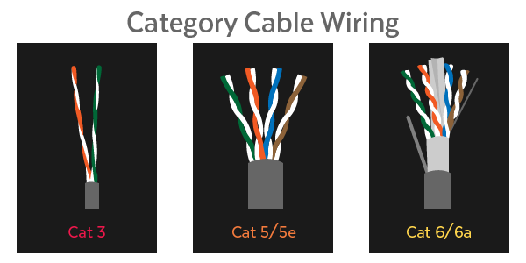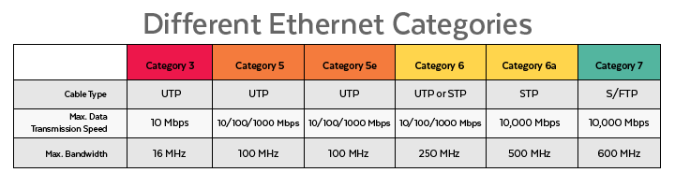
https://planetechusa.com/blog/ethernet-different-ethernet-categories-cat3-vs-cat5e-vs-cat6-vs-cat6a-vs-cat7-vs-cat8/

Why “twisted” pair?
Discovered over 100 years ago in early telephone technology
Reduces “cross-talk” between wires
One wire is for the signal, the other for ground reference

Hubs and Switches
Repeaters just take a signal on one side and retransmit on the other side, hopefully stronger and cleaner. Do this bit-by-bit. Repeater with multiple ports is a “hub”

Star topology has hubs with each node connected by a single cable to the hub

Bridges/switches read an entire packet, look up address and forward along the correct wire. “Hubs propagate collisions; switches do not.”

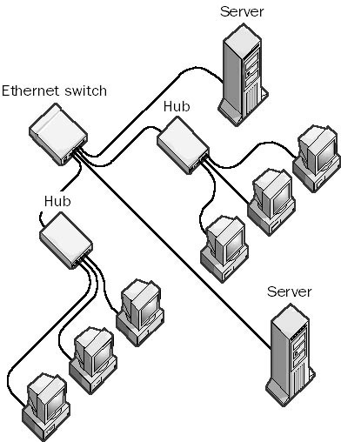
http://www.thenetworkencyclopedia.com/entry/ethernet-switch/

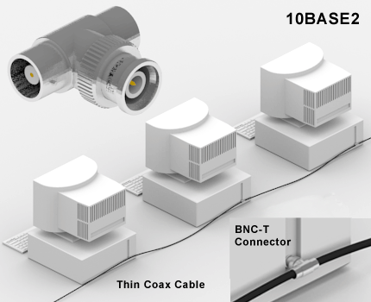
http://encyclopedia2.thefreedictionary.com/10Base2+thinnet+coaxial+cable

Switches learn which addresses are at each port and keep routing tables to speed up transmission and avoid collision

Ethernet Packets
Packets are basic unit of transmitting data over Ethernet
Contains a preamble and a frame, followed by a “gap”

Preamble made up of a sequence of 1’s and 0’s (ones and zeroes)
Allow synchronization on wire between sender and receiver

Gap is 12 bytes of no transmission, to allow the hardware to complete any processing

Ethernet Type II Frame (aka “DIX” frame):
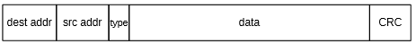

Dest and Src address are 48 bits each
Type is 16 bits and determines what’s in the data, e.g. IP = 0x0800
Data is whatever is being transmitted by the higher level protocol, e.g. IPv4 datagram
CRC is a 32 bit checksum calculated by the ethernet hardware

Ethernet Addresses
Addresses are meant to be unique on the network
OUI (Organizationally Unique Identifier) embedded in address assigned by IEEE
Bit to indicate wether globally or locally unique

Special addressing situations:
All 1’s is a “broadcast” packet – picked up by all cards on net
Promiscuous mode – allows ethernet card to receive packets w/ any address
Multicast – allows packet to be received by groups of cards (e.g. video multicast)

Collisions
Initial 10Mbps Ethernet used “broadcast bus” configuration, where all nodes are physically connected and physically experience all packets
Consequently, Ethernet spec includes provisions for dealing with collisions

Physically, signal propagates no faster than the speed of light, c
Different cables have speeds at some fraction of c, for example…

Coax cable in 1982, transmitted at 0.77c
In 0.1 micro-sec (at 10Mbps), signal travels, wait we can do this math…
(0.77)(3x10⁸ meters/sec)(1x10⁻⁷ sec) = 23.1 meters
So… at this speed, 1 bit can travel about 23 meters before next bit is sent

Slot time – 51.2 micro-secs, time to send 512 bits, 232 bits out, 232 bits back, and…
room for 48 “jam” bits, to indicate collisions

If a node is able to transmit for an entire slot, then it acquired the network and can continue sending

Collision detection and avoidance with “exponential back-off”:
- Listen before transmitting (“carrier detect”)
- If busy, wait for 96 bits
- Transmit while watching for collisions
- If collision detected…
  - Cease transmitting
  - Send jam bits
  - Choose random number of slots to wait, where number in a range that grows exponentially with each retry
  - Retry transmission
- If unable to complete transmission after 16 retries, then “give up”

Exponential back-off means that collisions become successively less likely each retry

10Mbps Ethernet has an efficiency of about 70%, including collisions and back-off

Faster!
100Mbps…
- More bits per second!
- Smaller/tighter diameter standards
- 100BASE-TX using Cat-5 cables
- Full-duplex (with two twisted pair)
- Station-to-station, without hubs… collision free!

Gigabit…
- Even more bits per second!
- Increased slot size to 4096 bits
- 1000BASE-T using Cat-6 cables
- Bi-directional and Full-duplex (with four twisted pair)

Gigabit communication is similar in speed to hard-disk access

10 Gigabit Ethernet (10GBASE-X)
40 Gigabit Ethernet (40GBASE-X)
100 Gigabit Ethernet (100GBASE-X) – products on the market today

Fastest?
InfiniBand – 2014, used to connect supercomputers for high performance computing

How fast?

300 Gigabits!

Umh, that’s...

300x10¹² bits per second

For more on speeds of various communication standards:
https://en.wikipedia.org/wiki/List_of_device_bit_rates

Wifi
Standards for Layer 1 (Physical) and Layer 2 (Data link)
Used for radio transmissions

Following notes some of the significant differences with Ethernet
Much more detail available in the texts on these and other considerations

Radio waves have their own unique considerations…
Signal strength decreases rapidly (1/distance²)
Interference by physical objects, possible passage or blockage
Reflected of waves, e.g. off walls in a room, can interfere
Two nodes may interfer with a third node, but not with each other
There is only one set of frequencies, and all devices must share!

Moving transmitters/receivers mean the picture changes constantly

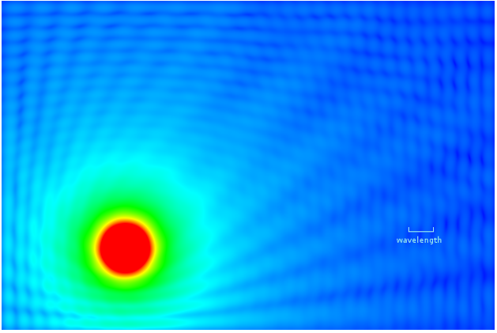
Interference between a signal and it’s partial reflections off walls in a room

Wifi uses pure collision avoidance, because it cannot detect collisions in progress
Watch the frequency and wait until it seems quiet, then transmit
Wifi protocol includes explicit Acks (acknowledgements) to ensure delivery
Error detection and correction codes included to address errors
Wifi was designed to be interoperable with Ethernet, so the frames look similar:

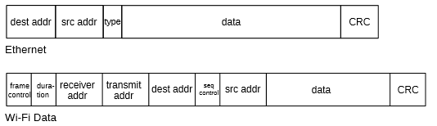

The receiver and transmitter addresses are used for the radios, and the dest addr and src addr are Ethernet addresses so that Wifi hotspots can be thought of as switches on an Ethernet network.

